1. Creating the database, use database, creating table “animlas”, creating table “adoptions”

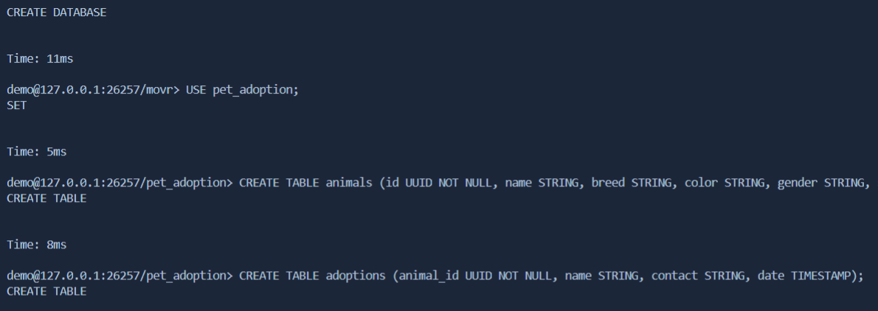

1. Show tables, Show columns from animals, Show columns from adoptions

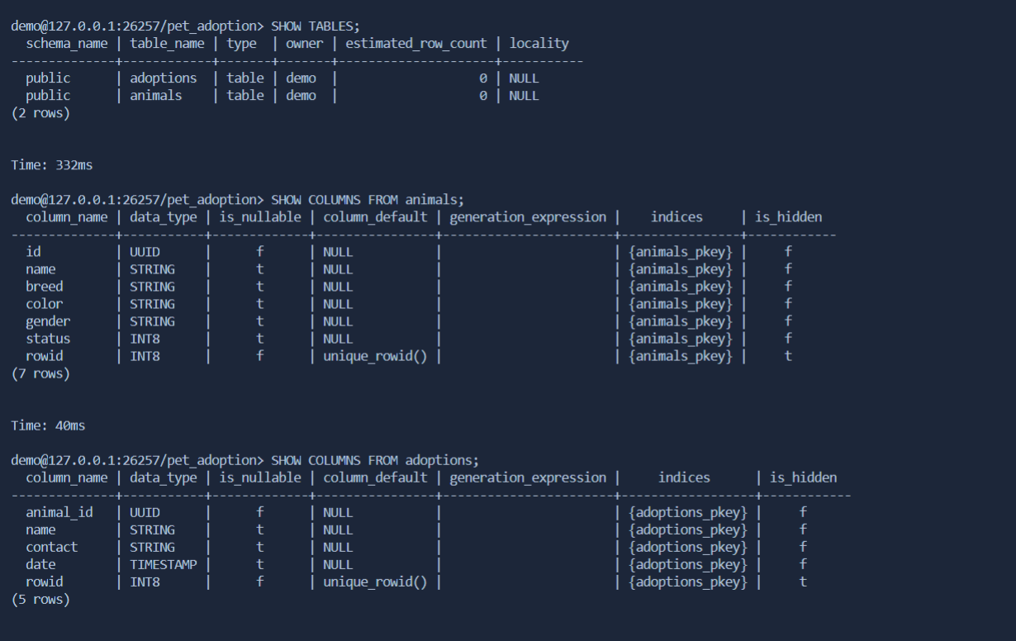

1. INSERT INTO animals, SELECT \* FROM animals , SELECT breed FROM animals

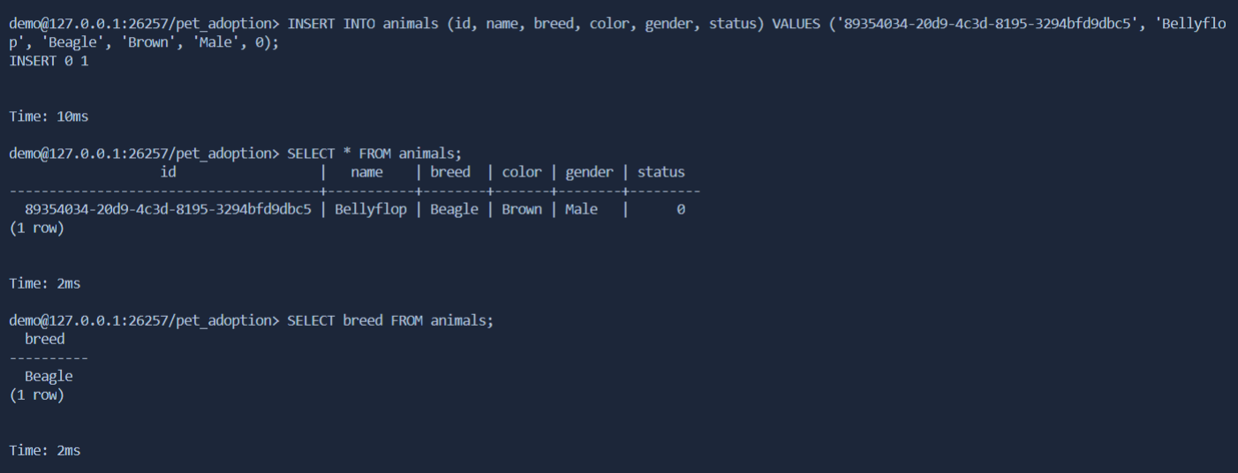

1. Select name from animals where gender = “female”, Select id from animals where status

